Abinger Parish Council: Forest Green Playground Proposal Update
Dear Resident,
Abinger Parish Council (APC) has been approached by residents interested in having a playground in
Forest Green. In response APC has formed a Playground Working Group, including residents and
APC Councillors to investigate a possible site, design, costs, funding and community consultation. The Working Group has made considerable progress on these issues and APC would now like to consult Forest Green residents before proceeding further.
Design:
At the forefront of the design is a playground sympathetic to its surroundings, ensuring that the character of the green remains unchanged.
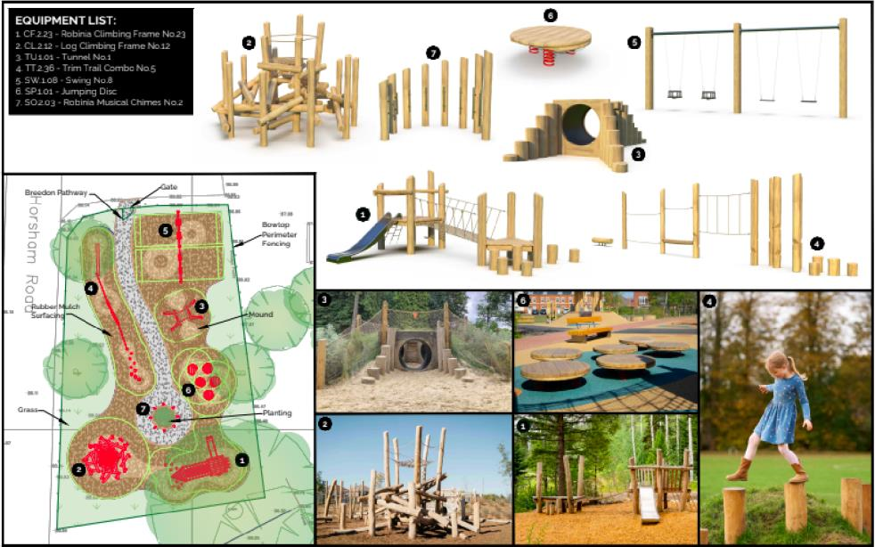
Please note this is an initial concept and not the final design.
Location:
The area between the Village Car Park and the Village Hall Car Park is the suggested site following surveys (donated) and guidance from specialist playground providers. Reasons include:
- Least impact on the openness of the green and flora and fauna
- Cost of installation
- Accessibility and proximity to village car parks
Fencing, gating and landscaping will pay particular attention to safety due to proximity to the road.

Funding:
The cost of the design and build will be raised by the working group from grants and donations from national projects such as the National Lottery, and local businesses and will not come from the precept of the Parish Council. APC will take on the running costs of insurance maintenance and inspections as part of the existing works for the other 3 playgrounds in the Parish estimated to be around £440 per annum.
Next Step
We value the community view, please let us know if you are in favour of a playground or not. If we do not hear from you using this form your view cannot be included in the democratic process. Please note we are unable to count your vote without your name and address on this form and by ticking either the In Favour or Against box.
* IN FAVOUR [ ]
* AGAINST [ ]
* Mandatory
Comments

Name: ......................................................................
Address:..........................................................................................................................................
Please complete this form (one per household) by Monday 10/06/2024 and return:
By post to: Beccy Anderson Parish Clerk, 9 Spencer’s Road, Horsham, West Sussex RH12 2JQ
By email: to the Parish Clerk at abingerpc@hotmail.com using an electronic form available on Abinger Parish Council website
http://www.abinger-pc.gov.uk/community/abinger-parish-council-13002/playgrounds/
APC will keep all personal information confidential.
Regards
Abinger Parish Councillors

